

Icon changes color changing boxes and homepage section should have some blue blocks
every black content required blue color
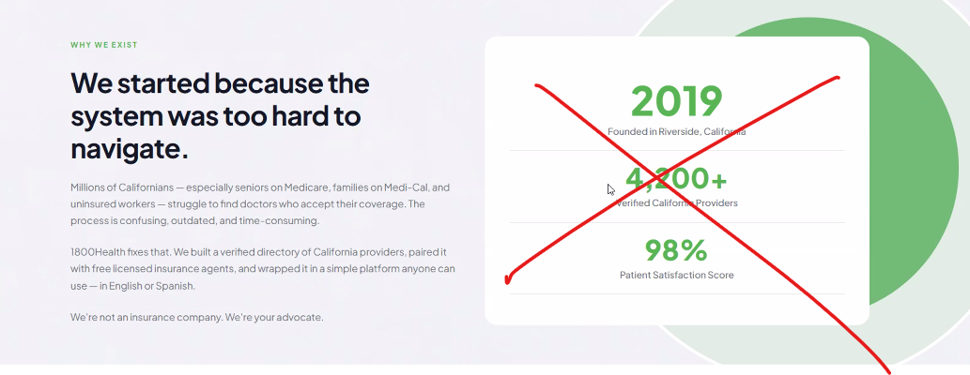
Remove the stats and move out for some images
turning color on button effect should match the brand color pallete
remove rating from everywhere
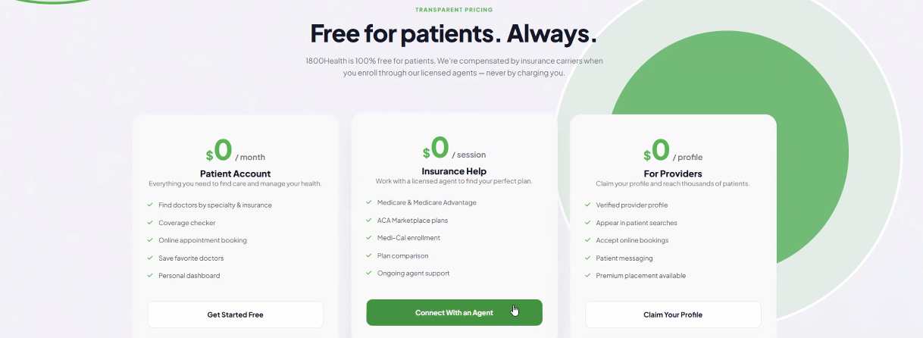
make one slide for the patient section only and don’t use free anywhere

