Feet Dreams Web Content

Home Page

Buy. Sell. Connect
With Feet Dreams, buyers discover authentic content and sellers earn with confidence. A trusted marketplace built around privacy, smooth transactions, and a community that values simplicity and respect.


How to Buy with Feet Dreams

01 Join for Free
Create your account in just a few steps and start exploring right away. Registration is simple, private, and designed to get you browsing without any complications.

02 Find What You Like
Browse profiles, explore different styles, and choose content that matches your preferences. Everything is organized to make discovery easy and comfortable.

03 Pay and Enjoy
Purchase securely through our trusted payment system and access your content with confidence. Your privacy and transaction safety remain a priority at every step.
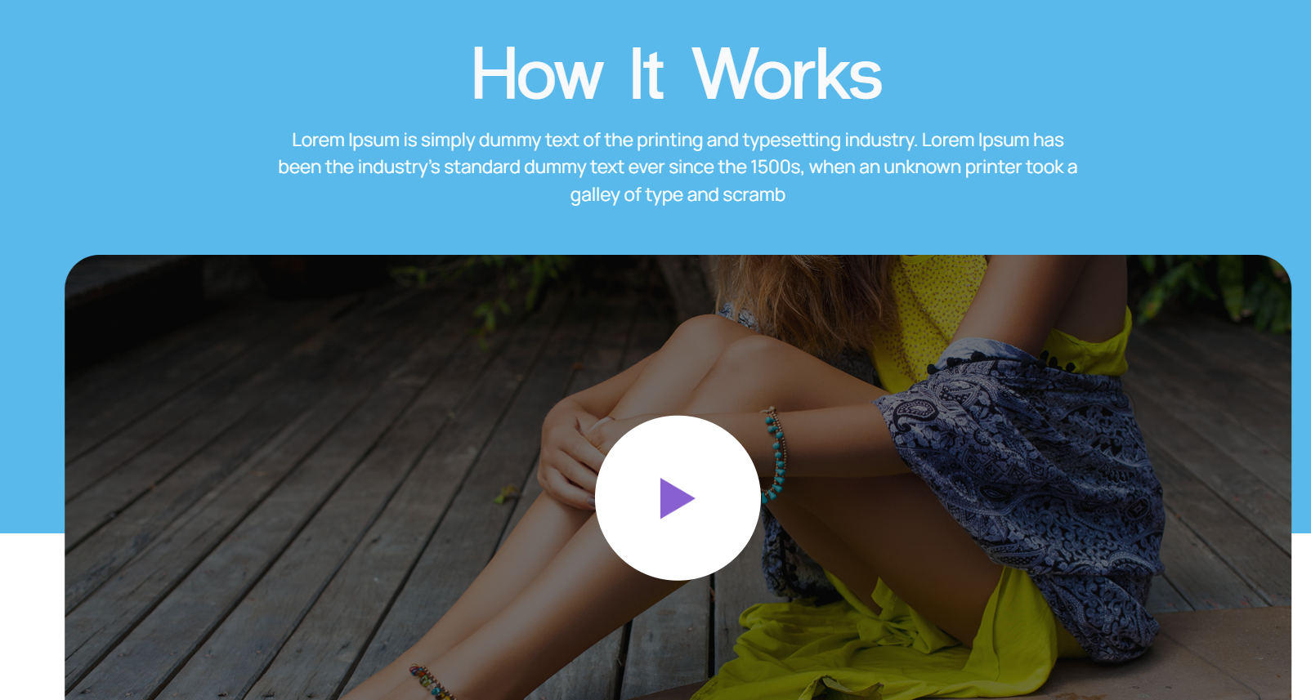
Simple. Private. Built for Real People.
No complicated systems. No confusing steps. Feet Dreams focuses on making connections easy while keeping everything secure and discreet. Take a closer look at how the platform works and why users feel comfortable exploring, sharing, and earning here.

Explore Profiles. Find Your Favorites.
Feet Dreams connects you with verified sellers who bring personality and creativity to their content. Browse with confidence and discover what captures your interest.

Trending Foot Content From Verified Sellers

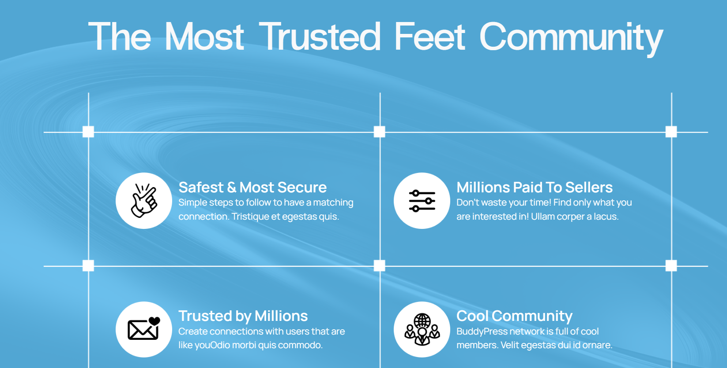

A Platform Built on Trust, Privacy, and Real Connections
Safe and Secure
Privacy isn’t something people want to think about constantly, but it needs to be there. Feet Dreams was created so buyers can explore and sellers can share without that lingering worry in the back of their minds.

Real Earning Opportunities
For sellers, it’s more than posting photos. Feet Dreams helps turn attention into real, confident earnings.
A Growing Community
Feet Dreams brings together people who understand the interest, creating a discreet community that feels personal and welcoming.
Comfortable Environment
Whether browsing or sharing, the platform is designed to feel private, respectful, and comfortable from the very start.

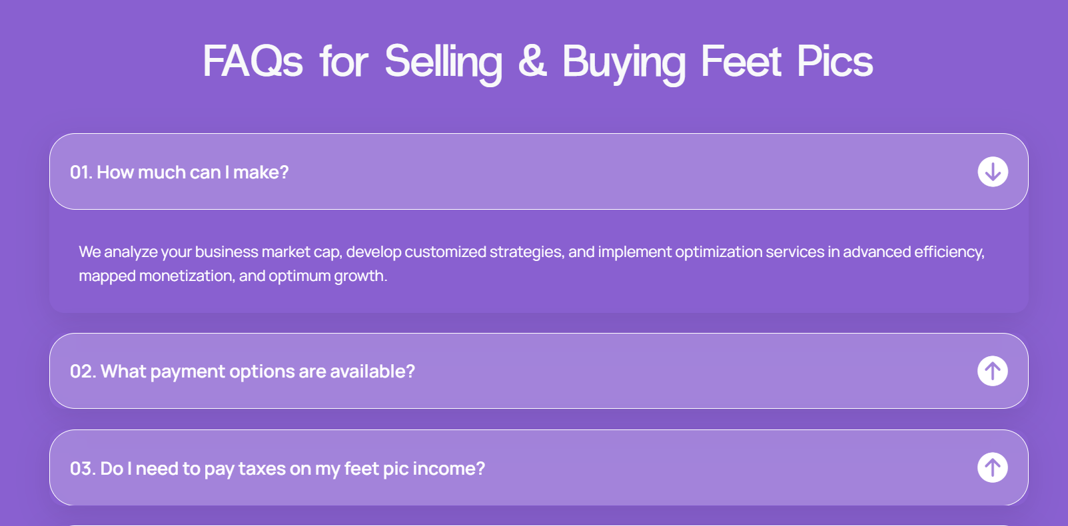

How do I purchase content on Feet Dreams?
You can browse seller profiles, explore available photos, and complete your purchase directly through the platform. The process is simple, and access to your content is provided after payment is confirmed.

How does Feet Dreams make sure sellers are genuine?
Accounts go through a review process before becoming active, helping maintain authenticity across the platform. This creates a more reliable environment where buyers can interact with confidence.

Will my activity remain private?
Yes. Privacy is treated seriously. Transactions are handled securely, and personal details are protected so users can explore or sell without unnecessary concerns about confidentiality.

Can buyers request personalized content?
Many sellers are open to custom requests. Once you connect with a creator, you can discuss preferences directly and agree on details that work for both sides.

Do I need a subscription to buy photos?
No subscription is required for buyers. You can purchase content individually whenever you choose, making the experience flexible and straightforward.
Is Feet Dreams safe to use?
Yes. Feet Dreams follows common U.S. platform security practices to protect both buyers and sellers. Accounts may go through identity verification, and the website uses SSL encryption to secure data during transactions. Payments are processed through trusted providers that follow industry security standards, helping ensure personal and financial information remains protected. Privacy is treated seriously, and user data is never shared without authorization.

- The Rise of Micro-Niche Creator Platforms: Why Smaller Communities Are Winning Big
- Why Foot Content Communities Are Growing Faster Than Traditional Creator Platforms
- From Side Hustle to Steady Income: Modern Ways Creators Are Monetizing Personal Content Online

Stay Connected for Updates and Exclusive Offers

Explore Page

Find Creators You’ll Love
Browse profiles, explore personalities, and discover content shared by real people in a secure and welcoming environment.
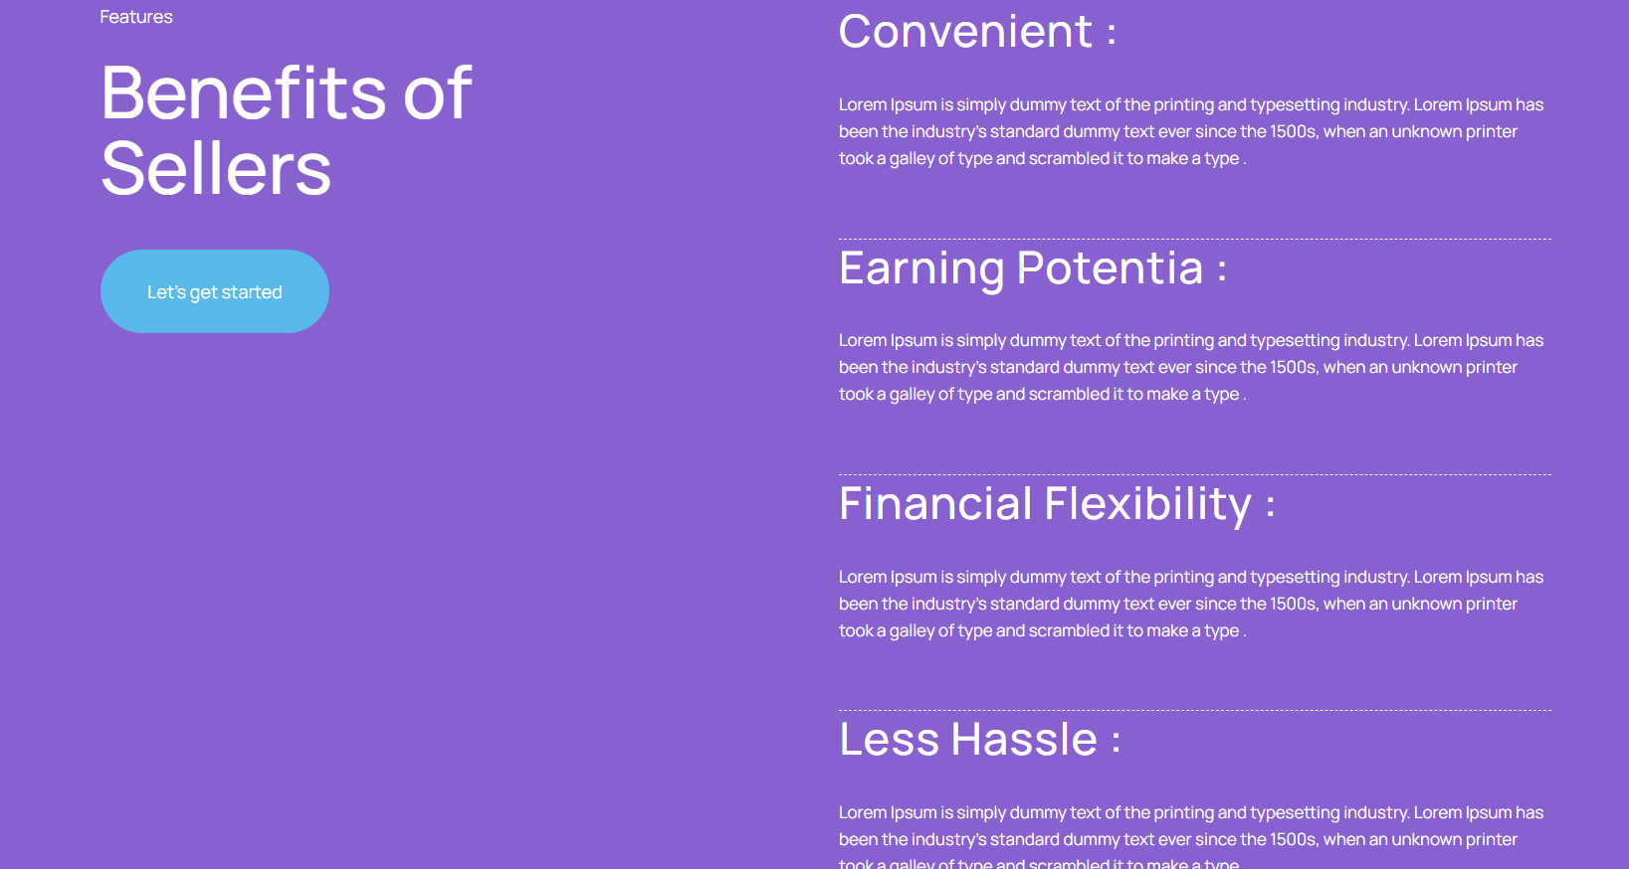
A Better Way to Share and Earn

Your Time, Your Pace
Not everyone wants another rigid schedule. Feet Dreams lets sellers upload when they feel like it, check messages when it suits them, and stay in control without pressure. It fits into real life instead of taking it over.

Turn Attention Into Income
There is something satisfying about being noticed. Here, that attention can actually lead somewhere. Sellers can share confidently, build interest over time, and earn in a way that feels surprisingly natural.

Money on Your Terms
Some people want extra spending money. Others want something more consistent. The platform gives flexibility to choose pricing, content, and effort level without anyone dictating how things should work.

Simple Enough to Enjoy
Technology should not feel like homework. Feet Dreams keeps things straightforward so sellers spend more time sharing and less time figuring out buttons, settings, and confusing steps.

Sellers Page


Find Sellers That Match Your Style

FAQs Page

Frequently Asked Questions
Finding the right platform should feel simple. Whether you are here to explore content or start selling, these answers cover the most common questions about how Feet Dreams works.

Buying on Feet Dreams
How do I actually buy content?
You just browse through seller profiles, find something you like, and complete the purchase through the platform. Once payment goes through, you’ll be able to access what you bought without waiting around.
Do I need to pay monthly to use the site?
No. Buyers don’t need a subscription. You can purchase content whenever you want, which makes it easier if you only want something occasionally.
Is this private?
Yes, and that’s important. Your personal details stay protected, and transactions are handled through secure systems so you’re not sharing information directly with sellers.
Can I ask sellers for custom photos?
In many cases, yes. Some creators are open to requests, so once you connect with someone, you can talk about what you’re looking for and see what they offer.
How do I know sellers are real people?
Accounts go through a review process before becoming active. It helps keep the platform more reliable and avoids the fake-profile problem people worry about on the internet.

Selling on Feet Dreams
How do I start selling?
You create an account, set up your profile, and upload your photos. After that, buyers can start finding your content. The process isn’t complicated, which is the whole point.
Do I get to choose my prices?
Yes. Sellers decide what they want to charge. Some people start lower and increase later, others set premium prices from the beginning. It depends on your approach.
How do payments work for sellers?
Payments are handled through the platform so everything stays organized. Sellers can track what they earn without guessing or chasing buyers for money.
Is there a limit to uploads?
There are options that allow more uploads, especially if someone wants to grow their content over time. It’s flexible depending on how active a seller wants to be.

Safety and General Questions
Is Feet Dreams safe to use?
The platform uses standard security practices you’d expect from an online service. Information is protected, transactions are encrypted, and systems are designed to reduce risk for both buyers and sellers.
Who is allowed to join?
Feet Dreams is for adults only. Users need to meet age requirements to create an account or participate on the platform.
What makes this different from other sites?
The biggest difference is focus. Instead of being lost on a huge platform, this is a niche space where people already understand the interest. That usually makes the experience feel more comfortable and less awkward.

Still Need Help?
If something isn’t clear, support is available. The goal is to keep things straightforward so people can focus on enjoying the platform instead of figuring out how it works.

Contact Us Page

We’re Here to Help
If you need support or just have a question, send a message and someone will get back to you. The goal is to keep things simple and stress-free so you can focus on enjoying the platform.

Our Blogs
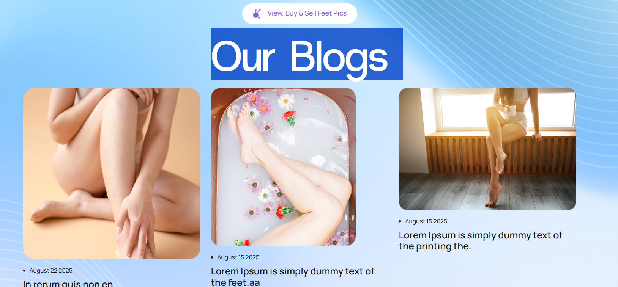
- The reason why the foot content communities are growing more rapidly than the traditional creator platforms.
Large creator platforms are initially exciting, but they may become overcrowded rather soon. New sellers are usually lost in the ocean of profiles, and buyers take even more time scrolling than they desire to reach a profile that will hold their interest. One of the reasons that smaller, niche communities are receiving increased attention in recent times is that frustration.
Once a platform is dedicated to a particular interest, it becomes a different experience. Sellers are communicating with individuals who have prior knowledge of what they are offering, that eliminates a good deal of awkwardness. Buyers can also save on time of searching and use it to be involved in contents they are enjoying. It is more personal, although it is all on the internet.

It also has the comfort factor that should not be overlooked. It is easier to participate in an environment full of like-minded people who are also curious. Human beings are not so apprehensive, seem to be more relaxed and usually more willing to interact.
To creators, such a specific audience can translate to increased visibility and greater opportunities of getting consistent income without having to have large followings. Smaller communities also just work in some cases, since people come there with the same expectations.

2. What Customers Are Seeking When Selecting Content Creators Online

Buyers are not just picking and choosing when they visit creator platforms. The profiles that gain attention and make purchases are dependent on several factors.

Authenticity has a significant role. The people who buy tend to react to the creators who seem real and not too pretentious. In digital communication a natural display may form a more powerful tone of connection even though it is digital.

Consistency also matters. Users who post on a regular basis are more likely to develop trust since the buyers will be aware of what they are going to get. Even minor updates can be an indication of trustworthiness and interest.

Another significant aspect is communication. Creators responding with a pleasant and understandable message makes the process more comfortable. It is easier to make buyers come back when they have been treated with respect.

Lastly, there is individuality. Artists who present character or a distinctive style tend to be favored more as compared to those who merge in the background. Memorability will help a lot.

Knowing these preferences further assists creators in their strategy as it assists them in enhancing the experience of the buyer on the whole site, which builds the bond between the two parties.
Confidence, Privacy, and Profit: What’s Driving the Popularity of Feet Content Marketplaces
The internet has opened the door to all kinds of income opportunities, but what’s interesting is how personal some of them have become. For many creators, selling niche content isn’t just about money. It’s tied to confidence too. Being able to share something on your own terms, without someone else setting the rules, can feel surprisingly empowering.
Privacy plays a huge role in that comfort. When a platform is designed specifically for a certain community, people tend to feel safer participating. There’s less fear of judgment and more control over how much you want to share. That alone makes a difference in whether someone decides to try it or not.
Then there’s the financial side, which honestly varies from person to person. Some treat it as extra spending money, while others turn it into something more consistent over time. The flexibility is part of the appeal. You’re not locked into hours or expectations.
Put those things together, confidence, privacy, and earning potential, and it makes sense why these marketplaces keep growing. They offer something that feels both practical and personal at the same time.

From Photos to Income: How Specialized Platforms Like Feet Dreams Are Changing Online Earning
Not long ago, making money online usually meant building a big following or learning complicated systems. Now it’s starting to look different. Specialized platforms have made it easier for people to earn from content without needing technical skills or huge audiences.
Feet Dreams is one example of how that shift is happening. Instead of worrying about websites, payment tools, or promotion strategies, sellers can focus on creating and sharing. The structure is already there, which lowers the barrier to getting started. That alone makes the idea less intimidating for beginners.
What’s interesting is how many people approach it casually at first. Someone might upload a few photos just to see what happens, then realize there’s actual demand. Over time, some turn it into steady income, while others keep it as something occasional. Both approaches work.
Buyers benefit too, because niche platforms make discovery easier. They know what they’re looking for, and they find it faster. That connection between focused demand and accessible supply is what makes these platforms effective.
Sometimes earning online isn’t about scale. It’s about the right space and the right audience.

Privacy Policy
Your privacy matters to us. Feet Dreams collects only the information needed to provide and improve the platform experience. This may include basic account details such as your name, email address, and payment information when you register or make a transaction. We use secure systems to protect your data and limit access only to authorized processes.
Personal information is never sold to third parties. It may be shared with trusted service providers only when necessary to operate the platform, such as payment processing or technical support. These partners are expected to follow standard data protection practices.
We also collect limited usage data to understand how people interact with the website. This helps improve performance, security, and user experience. Information gathered through cookies or analytics tools does not identify users personally unless you choose to provide those details.
You have the right to update or request removal of your information, subject to legal and operational requirements. By using the platform, you agree to the collection and use of information as described in this policy.
If you have questions about privacy or data protection, you can contact our support team for assistance.

Terms & Conditions
By accessing or using Feet Dreams, you agree to follow the terms outlined here. The platform is intended for adults only, and users must meet age requirements to create accounts or participate. You are responsible for maintaining accurate account information and protecting your login credentials.
Feet Dreams provides a marketplace that connects buyers and sellers. We do not own the content uploaded by users, but we reserve the right to review, remove, or restrict material that violates guidelines or applicable laws. Users are responsible for ensuring that their content complies with platform rules and legal requirements.
Payments and transactions are processed through secure third-party providers. Fees, pricing, and subscription options may change over time, but updates will be communicated clearly within the platform.
We may update or modify features to improve the service. Continued use of the platform after changes means you accept the updated terms.
Feet Dreams is not responsible for disputes between users, though we may assist in resolving issues when possible. Misuse of the platform may result in account suspension or termination.
For questions about these terms, please contact support.

Refund Policy
Feet Dreams aims to provide a smooth and fair experience for both buyers and sellers. Because digital content is delivered immediately after purchase, most sales are considered final. Once content has been accessed or downloaded, refunds are generally not available.
However, exceptions may apply in certain situations. If there is a technical issue, duplicate charge, or failure to receive purchased content, users can contact support for review. Each request is evaluated individually to determine an appropriate resolution.
Subscription services, where applicable, may be canceled according to the billing terms shown at the time of purchase. Canceling a subscription typically prevents future charges but does not automatically refund previous payments unless required by law.
Feet Dreams reserves the right to refuse refund requests that appear abusive or inconsistent with normal usage policies. Our goal is to maintain fairness while protecting both creators and buyers.
If you believe there has been an error with your purchase, contacting support promptly will help resolve the issue faster.

Cookies Policy
Feet Dreams uses cookies and similar technologies to improve how the website functions and to provide a better user experience. Cookies are small data files stored on your device that help remember preferences, maintain login sessions, and analyze how visitors interact with the platform.
Some cookies are essential for the website to operate properly, such as keeping users logged in or securing transactions. Others help us understand usage patterns so we can improve performance and features over time. These analytics tools collect general information but do not identify individuals personally unless voluntarily provided.
Users can manage cookie preferences through their browser settings. Disabling certain cookies may affect how parts of the website function, but you can still browse most areas.
By continuing to use Feet Dreams, you agree to the use of cookies as described in this policy. We may update cookie practices occasionally to reflect changes in technology or regulations.
If you have questions about how cookies are used, you can contact our team for more information.
