Location Page – Story Bridge Agency
Keyword: Children’s Book Marketing
Location: Texas


CHILDREN’S BOOK MARKETING IN TEXAS
From Houston to Dallas, Austin to San Antonio, Story Bridge Agency supports children’s book authors across Texas with thoughtful, ethical, and long term marketing strategies designed specifically for books written for young readers.
For over 10 years, our team has worked with 500+ children’s authors nationwide, helping them move beyond simply publishing a book and into building real visibility, trusted presence, and meaningful audience growth.
Your story deserves more than being listed online. It deserves to be discovered.
Primary CTA: Get a Quote
Secondary CTA: Book a Consultation


Why Texas Children’s Authors Choose Story Bridge Agency
Texas has one of the largest education systems in the United States. It also has a strong independent author community, homeschooling networks, public libraries, and school districts that actively engage with children’s literature.

Supporting First Time and Established Authors in Texas
Many authors come to us feeling unsure about what happens after publication.
We guide:
• First time authors navigating their first launch
• Authors relaunching previously published titles
• Series creators building long term brand presence
• Educational authors targeting school networks
• Independent authors strengthening Amazon presence
Our role is to simplify the process, provide structure, and remove confusion.

10 Years of Experience Supporting Authors Nationwide
Story Bridge Agency has spent a decade working alongside authors across the United States.
Over that time, we have:
• Supported 500+ children’s book authors
• Helped build successful author portfolios
• Guided first time authors through launches
• Assisted established authors with relaunch strategies
• Strengthened Amazon presence and discoverability
• Built long term author branding strategies
While we do not promise overnight results, we focus on steady growth, meaningful visibility, and building trust with your audience.
Children’s book marketing requires patience, consistency, and understanding how adults choose books for children. That is where our experience matters.

Children’s Book Marketing Services for Texas Authors
We provide structured, ethical, and personalized marketing strategies designed specifically for children’s authors in Texas.
Our services include:
• Amazon page optimization and keyword research
• Category positioning for children’s genres
• Book launch and relaunch planning
• Parent focused social media strategy
• School and library outreach guidance
• Author branding development
• Email marketing systems
• Blogger and influencer outreach
• Review growth strategies
• Publishing and portfolio positioning support
Whether you are based in Houston, Dallas, Austin, Fort Worth, El Paso, or anywhere across Texas, our team can support you remotely while maintaining personal communication and clear guidance.

Marketing Children’s Books in Texas Requires Local Awareness
Texas is unique.
It has:
• Large homeschooling communities
• Strong faith based school networks
• Public school districts with independent review processes
• Regional book fairs and literacy programs
• Active parenting communities
A children’s book that succeeds here must be positioned carefully and professionally.
We help align your book’s messaging so it speaks clearly to the adults who make purchasing decisions while preserving the heart of your story.
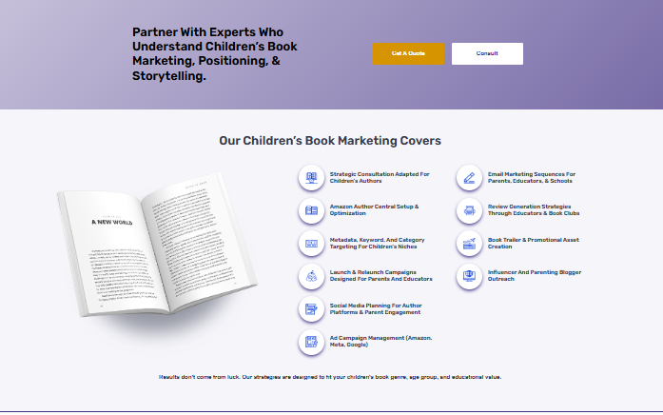

Ready to Help Your Story Reach Texas Readers?
Your book was written for a reason.
Let’s build the visibility it deserves.
Primary CTA: Get a Quote
Secondary CTA: Book a Consultation

Serving Authors Across Texas
We support children’s authors in:
• Houston
• Dallas
• Austin
• San Antonio
• Fort Worth
• El Paso
• Arlington
• Plano
• Corpus Christi
• Lubbock
• And throughout Texas
Even if you are located outside Texas but want to target Texas readers, we can build a localized strategy aligned with your goals.

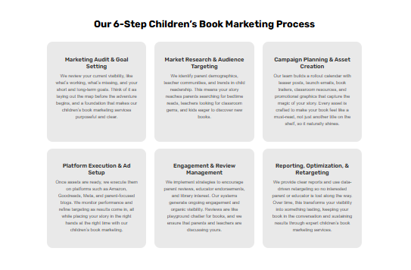

Our 6 Step Children’s Book Marketing Process in Texas
Step 1 – Understand Your Story
We begin by learning about your book, your goals, and your ideal audience. Every strategy begins with clarity.
Step 2 – Research Texas Audience Behavior
We evaluate how parents, educators, and communities in Texas discover and evaluate children’s books.
Step 3 – Optimize Discoverability
We improve your book’s visibility across online platforms through structured keyword strategy and professional positioning.
Step 4 – Build Author Credibility
We strengthen your author brand, improve presentation, and help build trust with families and schools.
Step 5 – Expand Outreach
We explore outreach strategies that support exposure beyond online marketplaces.
Step 6 – Monitor and Adjust
We review progress and refine strategies to ensure consistent, steady growth.
Marketing children’s books is not a one time campaign. It is an ongoing visibility strategy.


Why Experience and Trust Matter in Children’s Book Marketing
With 10 years of experience and hundreds of authors supported, Story Bridge Agency understands the responsibility that comes with marketing children’s literature.
We position your book in a way that feels trustworthy and aligned with community values.
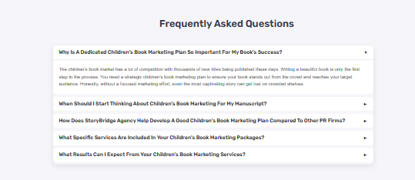

Frequently Asked Questions
Do I need to live in Texas to work with you?
No. We work with authors nationwide. This page is designed for authors who want to market their book in Texas.
How long does children’s book marketing take?
Marketing is a steady process. Many authors begin seeing measurable improvements within several months, depending on their starting point and goals.
Can you help if my book is already published?
Yes. Many of the 500+ authors we have worked with came to us after publication.
Do you guarantee results?
We do not guarantee rankings or sales. We focus on professional strategy, steady improvement, and long term visibility.
Is your agency physically located in the United States?
Yes. Our USA office details are available in the website footer, and we support authors nationwide.

